//SPDX-License-Identifier: Unlicensed

pragma solidity ^0.8.0;

contract Database{

    struct student{

        int ID;

        string _fname;

        string _lname;

    }

    int public Count = 0;

    mapping(int => student) public stdRecords;

    function addNew(int _id, string calldata _fname, string calldata _lname) public{

                        Count+=1;

                        stdRecords[Count] = student(_id, _fname, _lname);

                    }

    event received(address user, uint amount);

    receive() external payable{

        emit received(msg.sender, msg.value);

    }

}

Database Contract Owner: 0xAb8483F64d9C6d1EcF9b849Ae677dD3315835cb2

Database Contract Address: 0xa131AD247055FD2e2aA8b156A11bdEc81b9eAD95

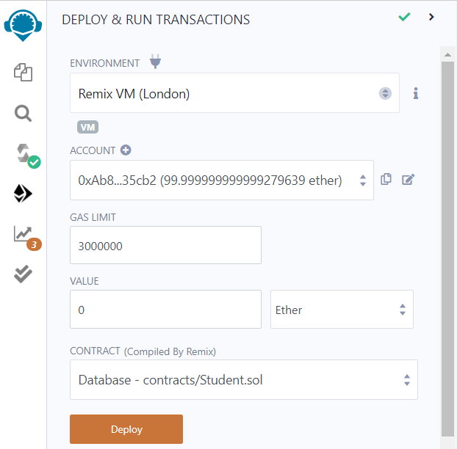

Add New Student

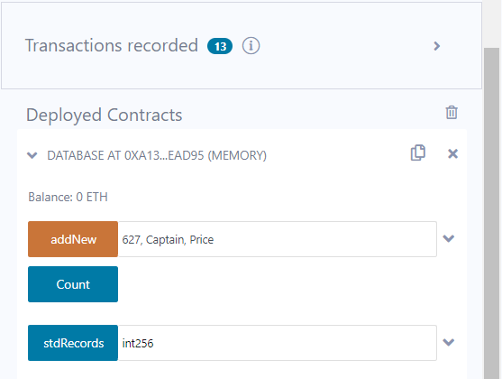

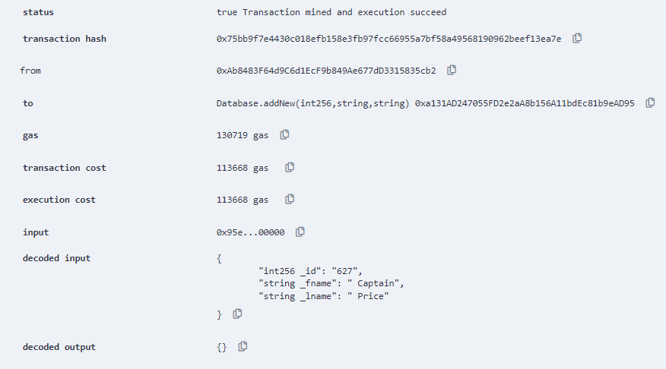

Gas cost for Adding new Student to contract

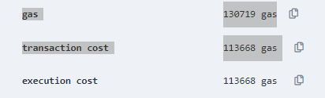

Return Count of Students in Contract

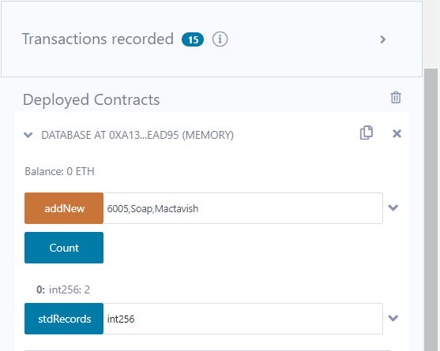

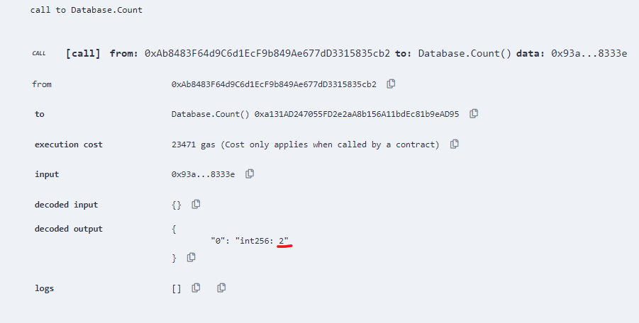

Gas cost to get Count of Students in record



Search Student in Contract Records

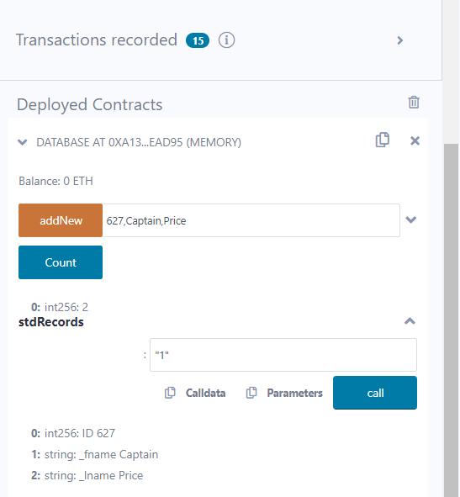

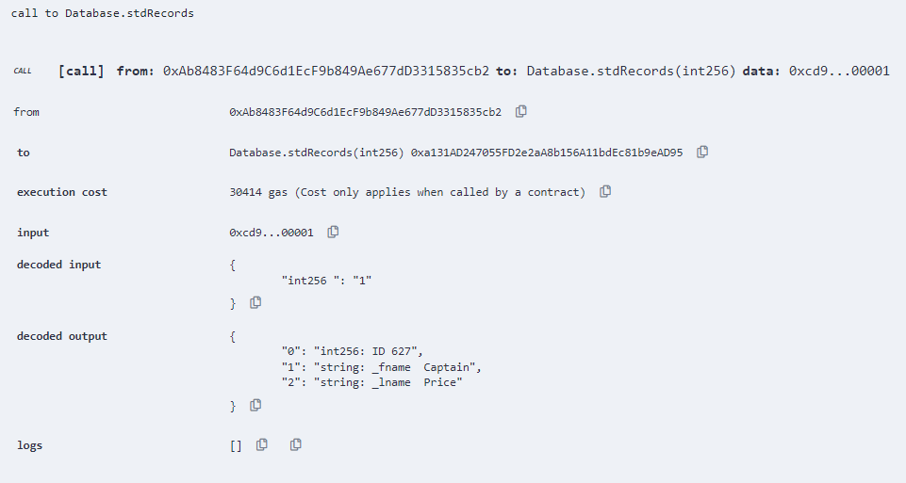

Gas cost to Search Student in record

